M74 SPIRAL GALAXY 9.2
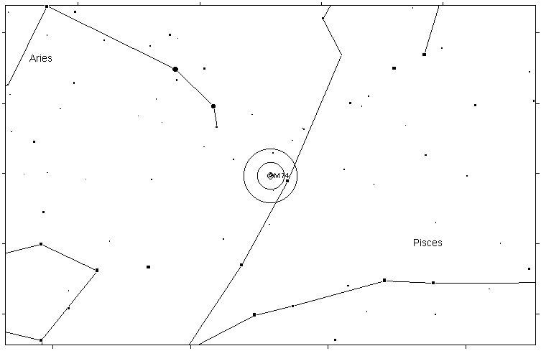
M77 SPIRAL GALAXY 8.8
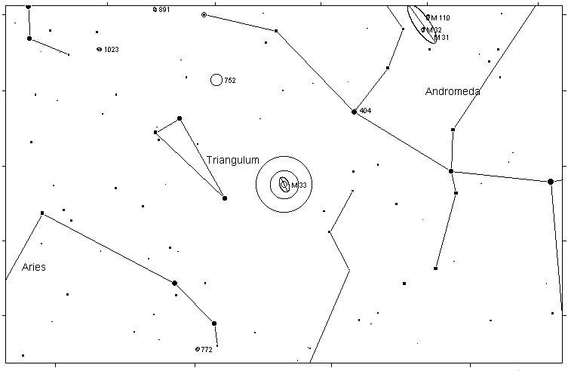

M33 SPIRAL GALAXY 5.7
M31 SPIRAL GALAXY 3.4
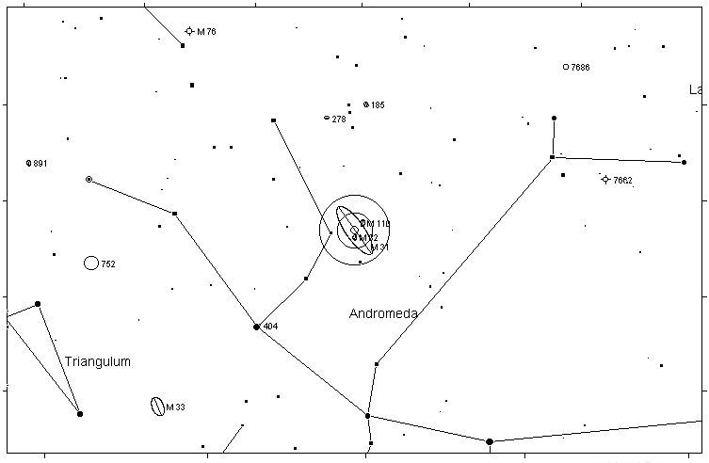

M32 ELLIPTICAL GALAXY 8.2
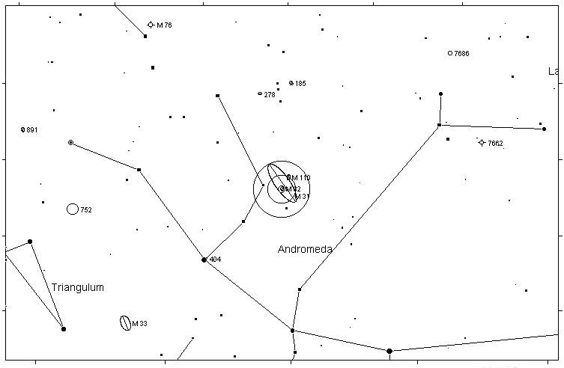
M110 ELLIPTICAL GALAXY 8.0
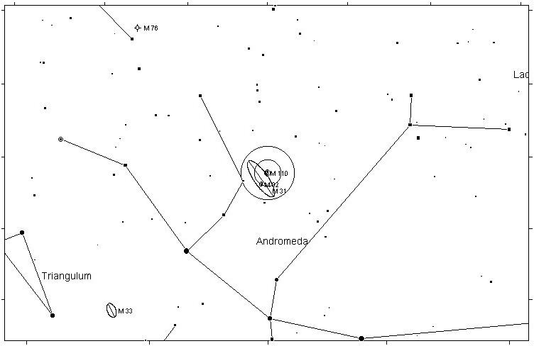

M52 OPEN CLUSTER 6.9
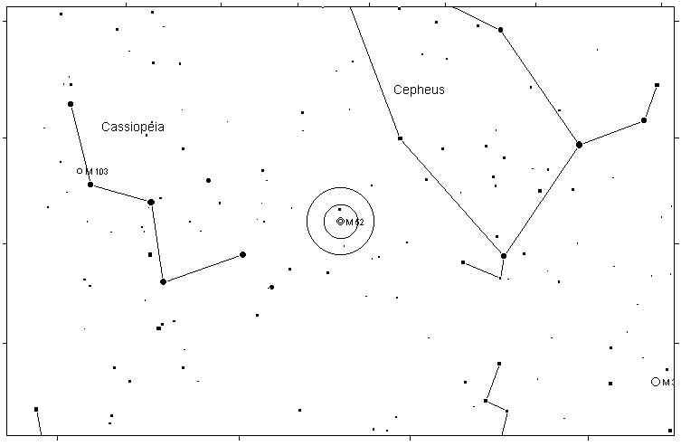
M103 OPEN CLUSTER 7.4
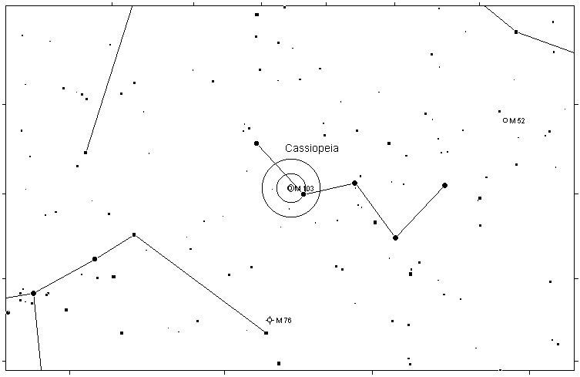

M76 PLANETARY NEBULA 10.1
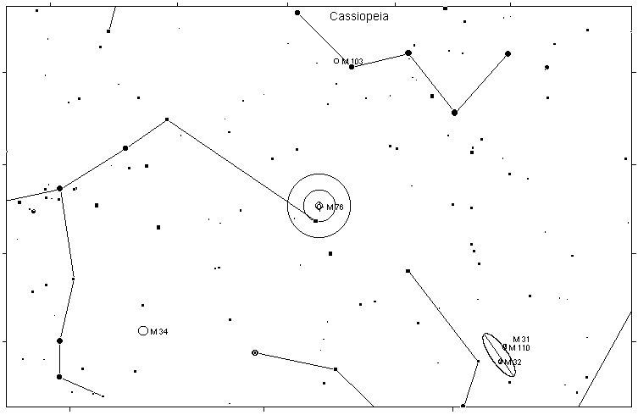
M34 OPEN CLUSTER 5.2
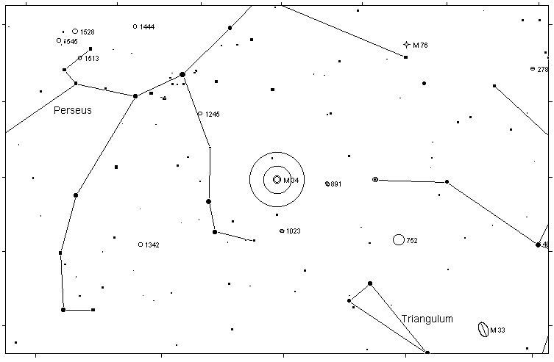

M45 OPEN CLUSTER 1.2
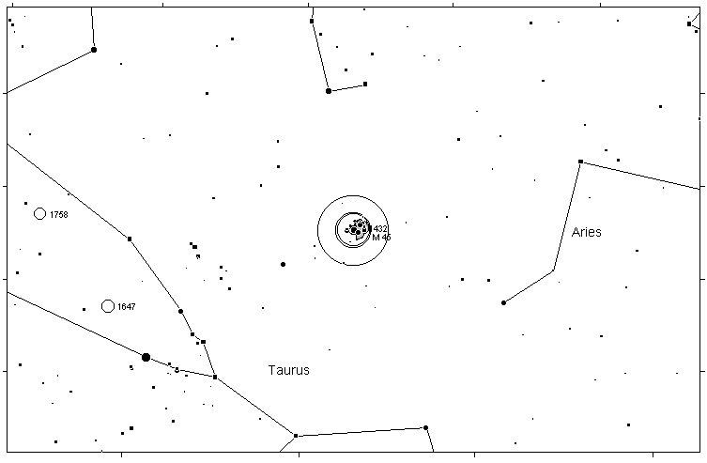
M79 GLOBULAR CLUSTER 8.0
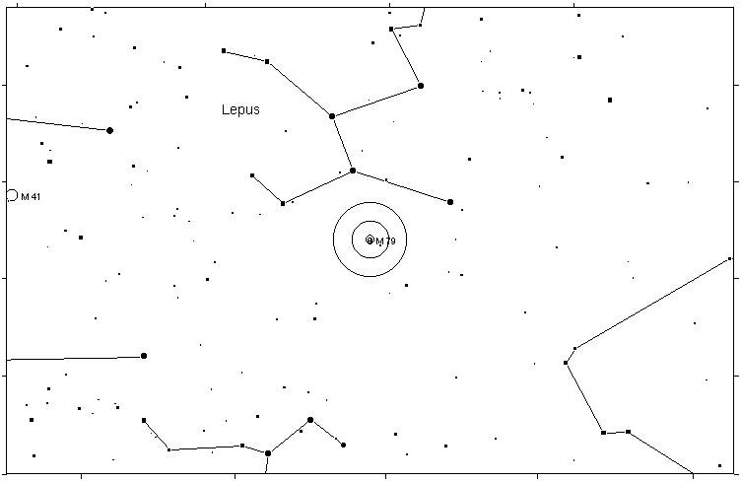

M42 DIFFUSE NEBULA 4.0
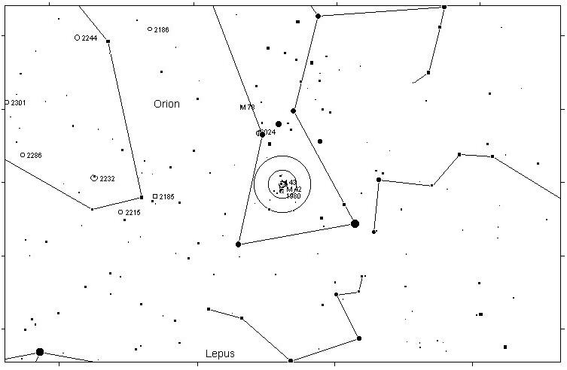
M43 DIFFUSE NEBULA 9.0
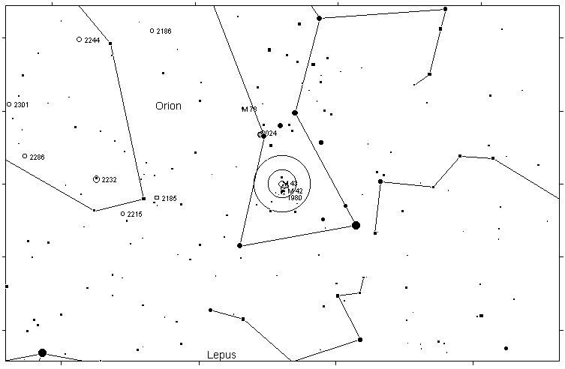

M78 DIFFUSE NEBULA 8.0
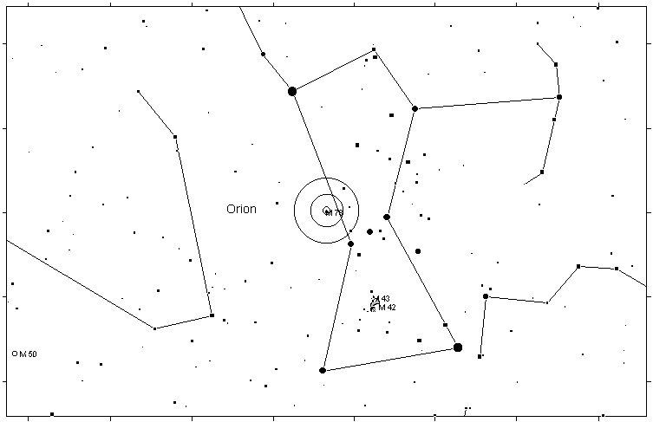
M1 SUPERNOVA REMNANT 8.4
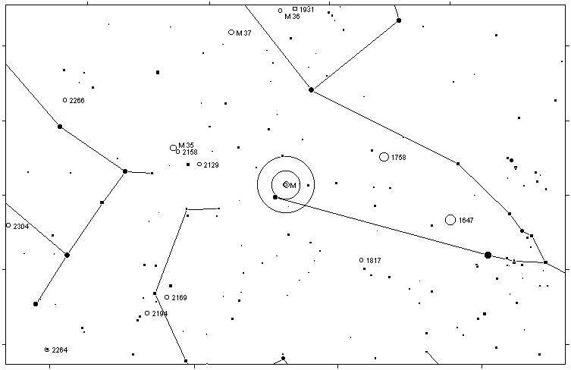

M35 OPEN CLUSTER 5.1
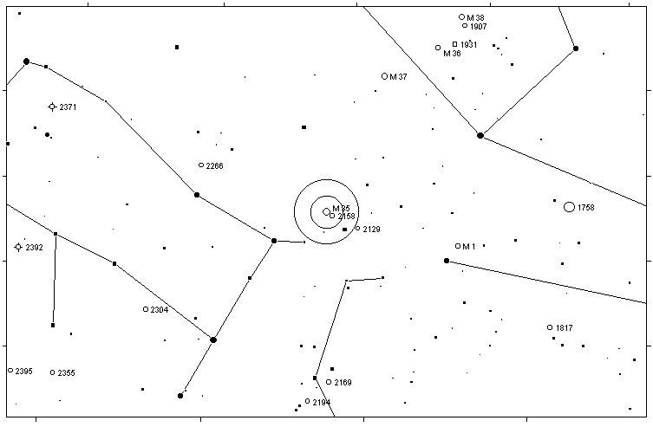
M37 OPEN CLUSTER 5.6
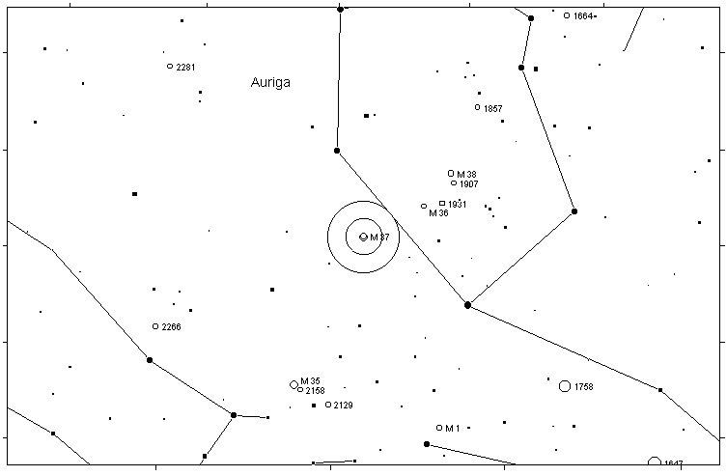

M36 OPEN CLUSTER 6.0
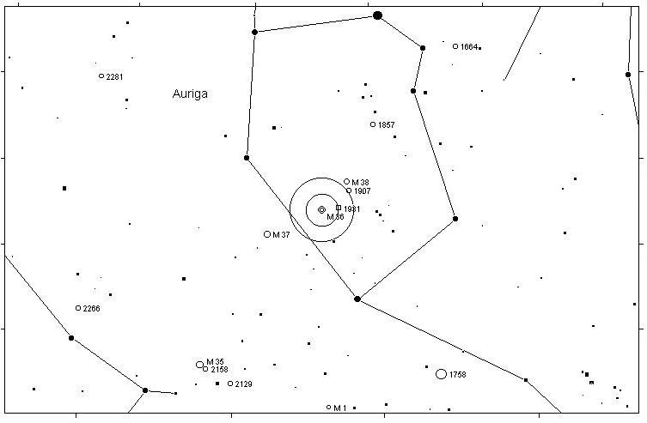
M38 OPEN CLUSTER 6.4
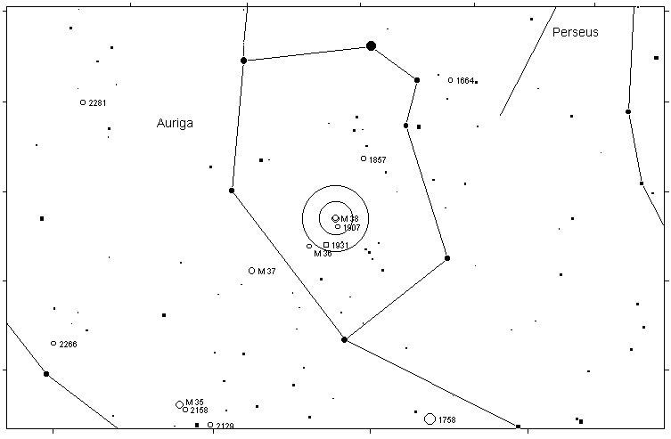

M41 OPEN CLUSTER 4.5
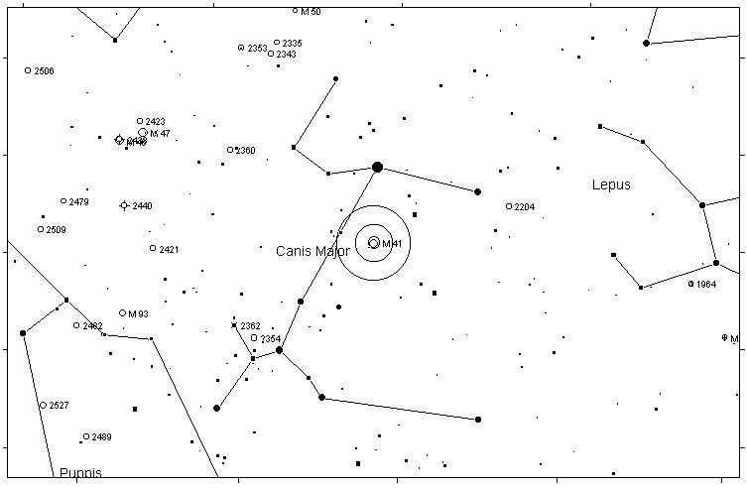
M50 OPEN CLUSTER 5.9
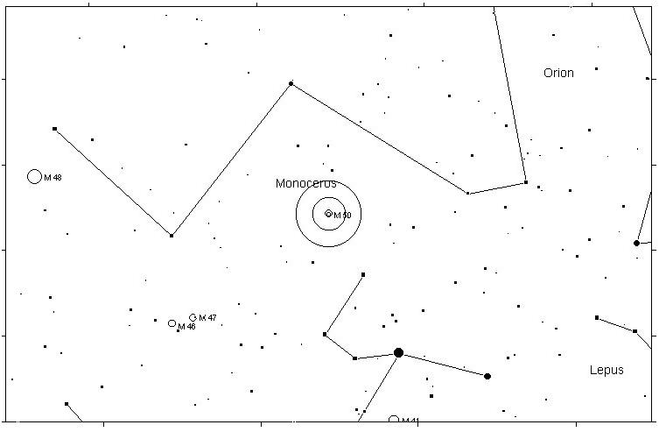

M47 OPEN CLUSTER 4.4
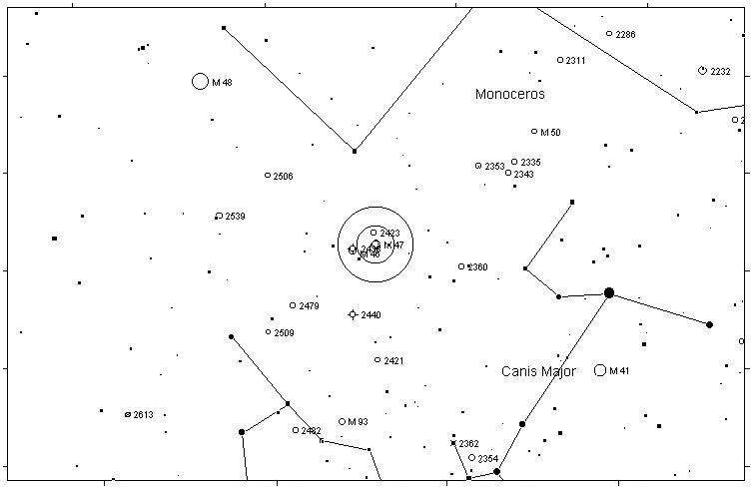
M46 OPEN CLUSTER 6.1
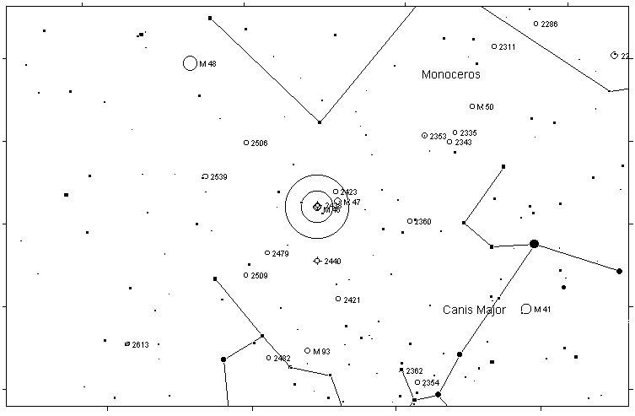

M93 OPEN CLUSTER 6.2
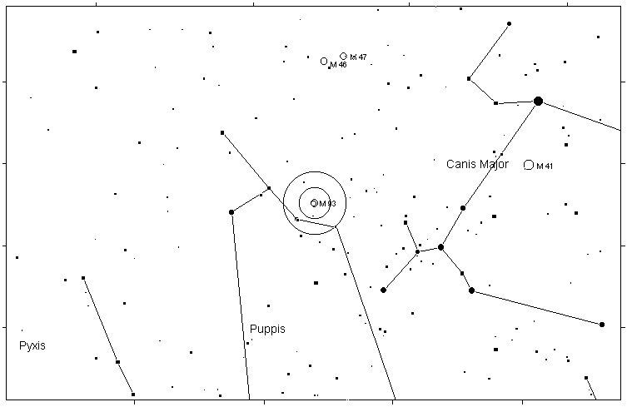
M48 OPEN CLUSTER 5.8
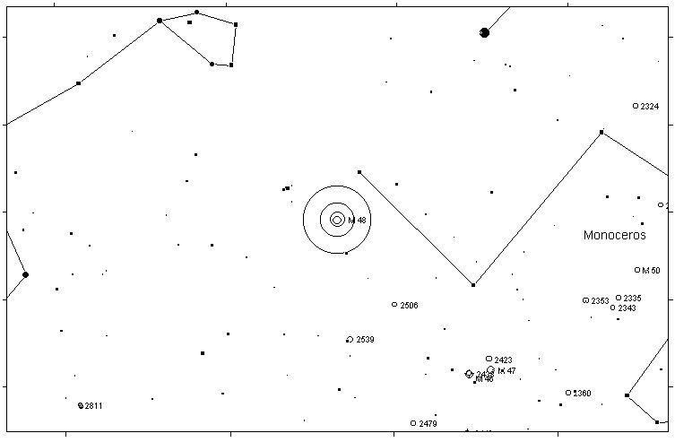

M44 OPEN CLUSTER 3.1
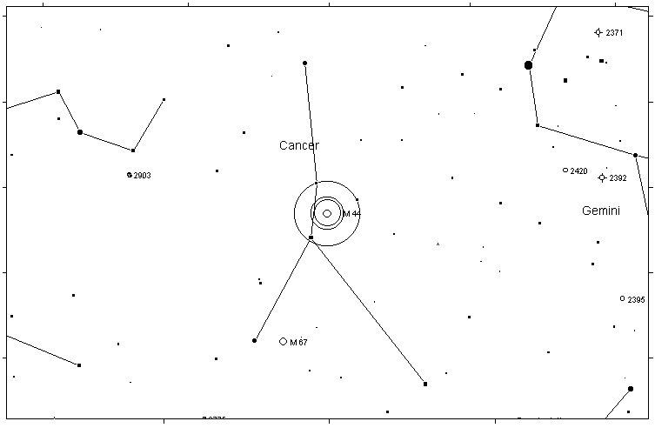
M67 OPEN CLUSTER 6.9
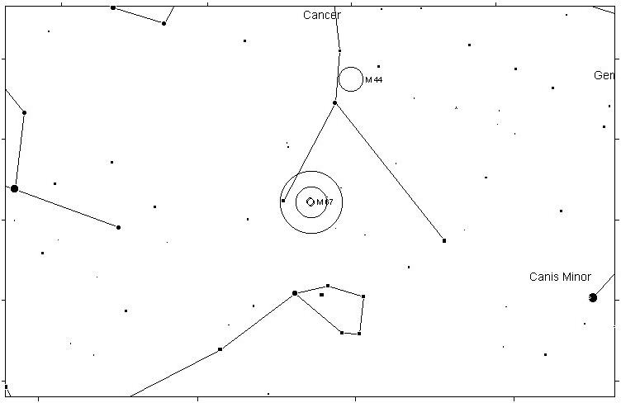

M81 SPIRAL GALAXY 6.8
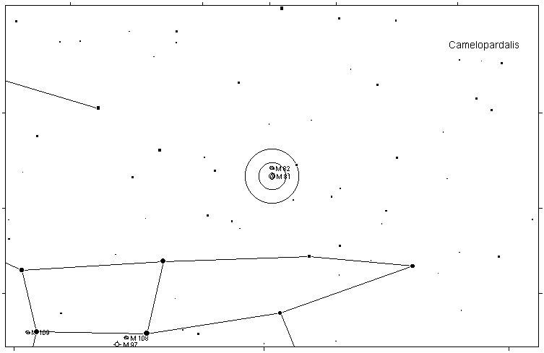
M82 IRREGULAR GALAXY 8.4
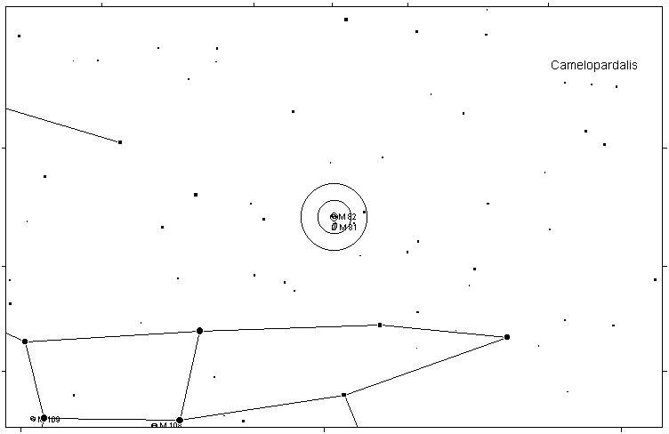

M108 SPIRAL GALAXY 10.0
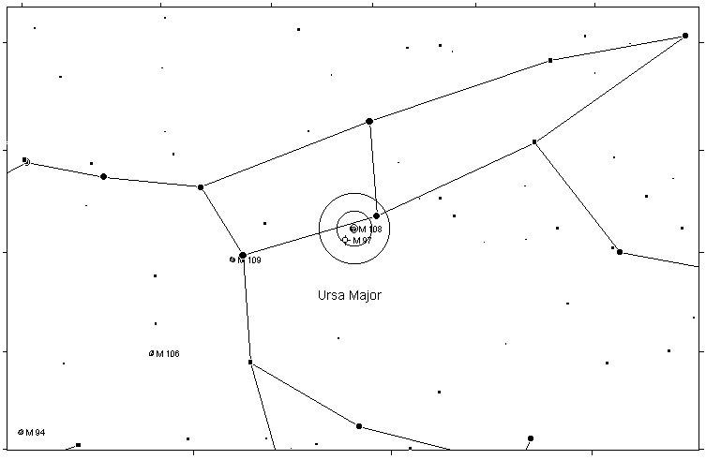
M97 PLANETARY NEBULA 9.9
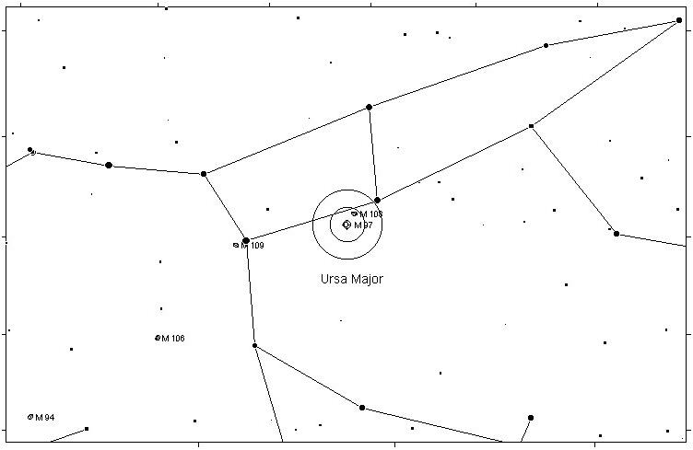

M109 SPIRAL GALAXY 9.8
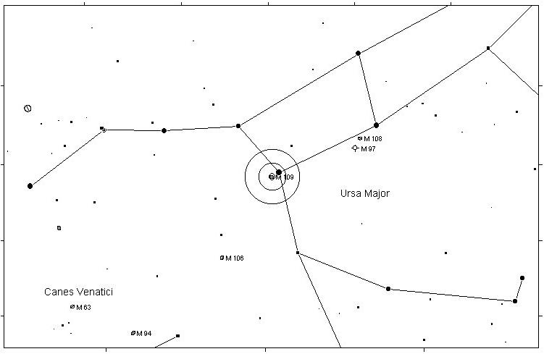
M106 SPIRAL GALAXY 8.3
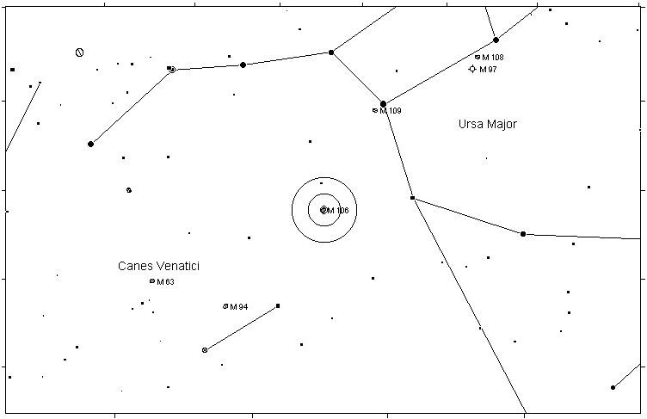

M40 DOUBLE STAR 8.0
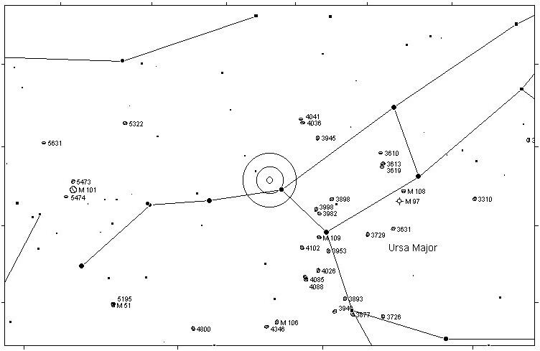
M95 SPIRAL GALAXY 9.7
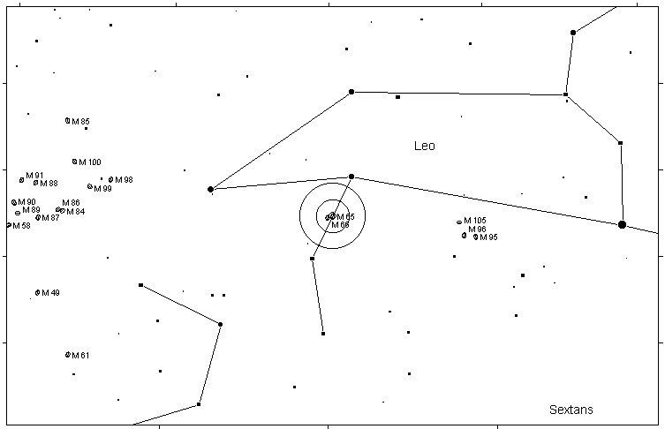

M96 SPIRAL GALAXY 9.2
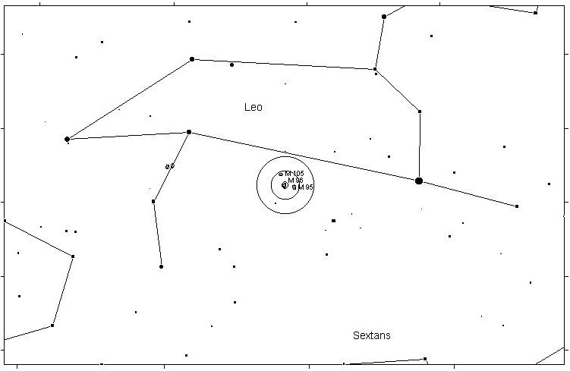
M105 ELLIPTICAL GALAXY 9.3
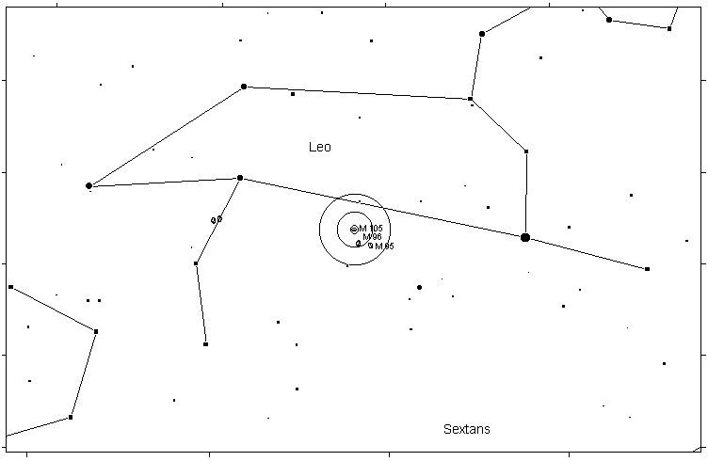

M65 SPIRAL GALAXY 9.3
M66 SPIRAL GALAXY 9.0
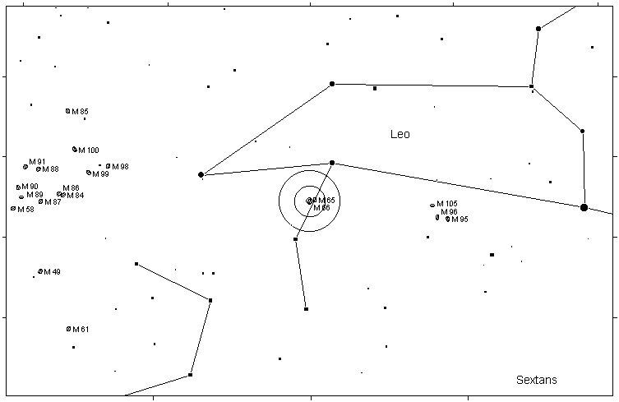

M101 SPIRAL GALAXY 7.7
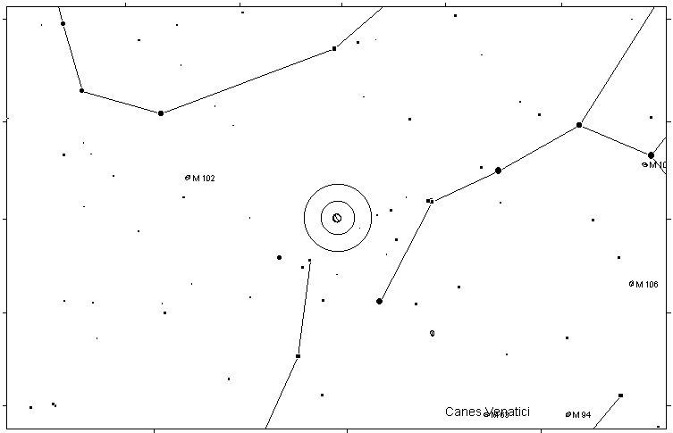
M51 SPIRAL GALAXY 8.1
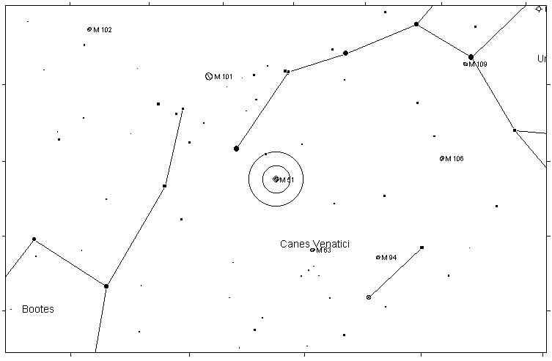

M63 SPIRAL GALAXY 8.6
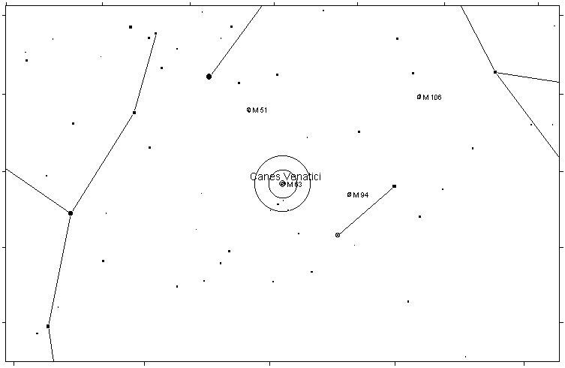
M94 SPIRAL GALAXY 8.1
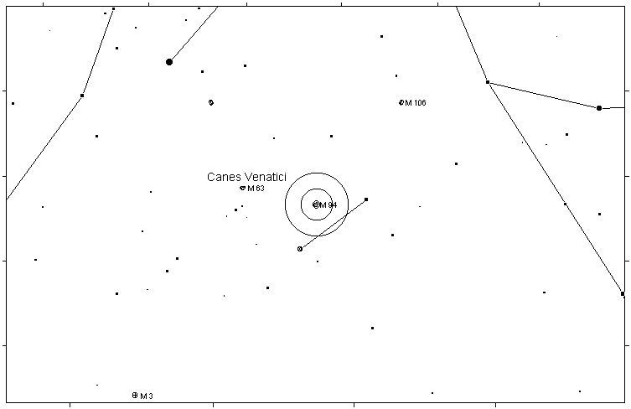

M3 GLOBULAR CLUSTER 6.4
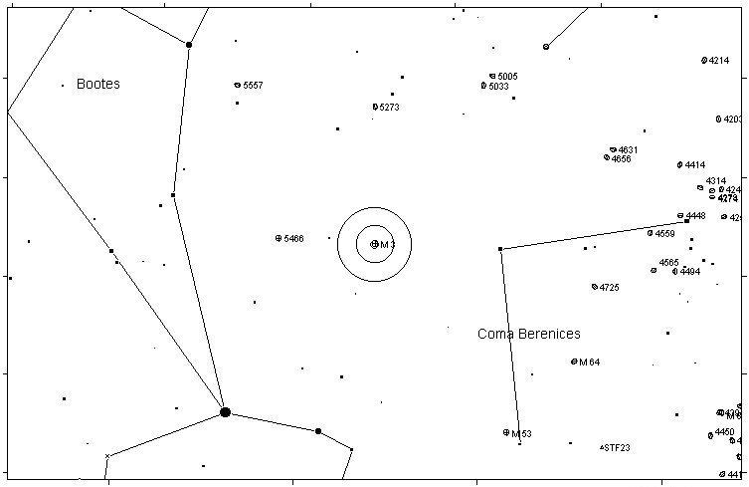
M53 GLOBULAR CLUSTER 7.7
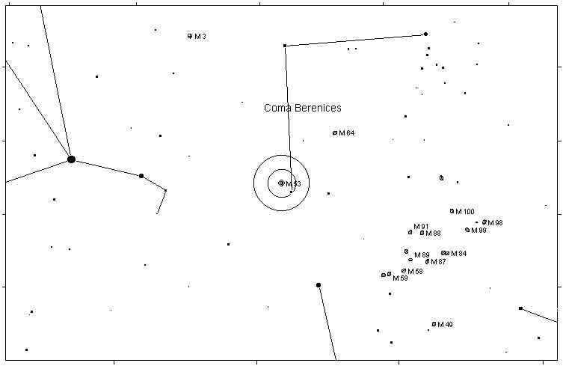

M64 SPIRAL GALAXY 8.5
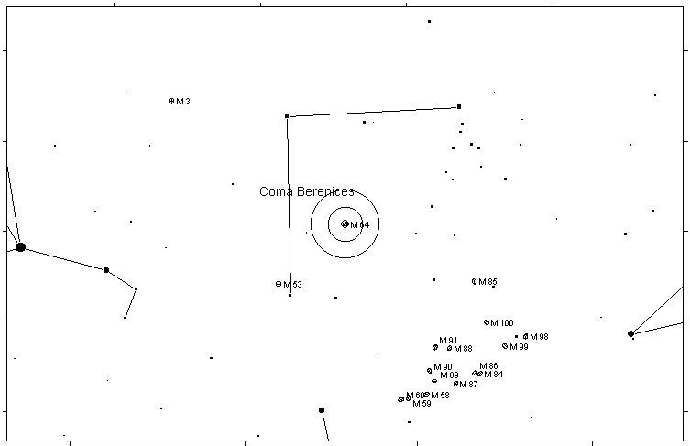
M60 ELLIPTICAL GALAXY 8.8

M59 ELLIPTICAL GALAXY 9.8

M58 SPIRAL GALAXY 9.8
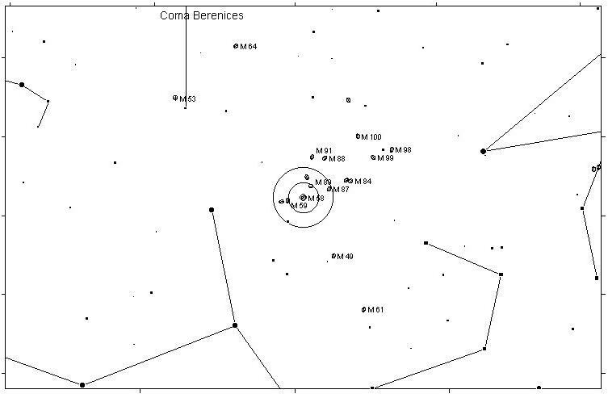
M89 GALAXY 9.8

M90 SPIRAL GALAXY 9.5
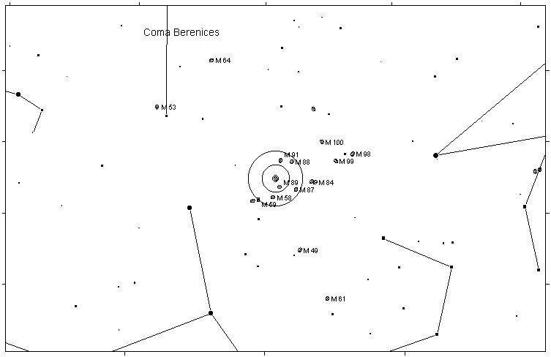

M88 SPIRAL GALAXY 9.5
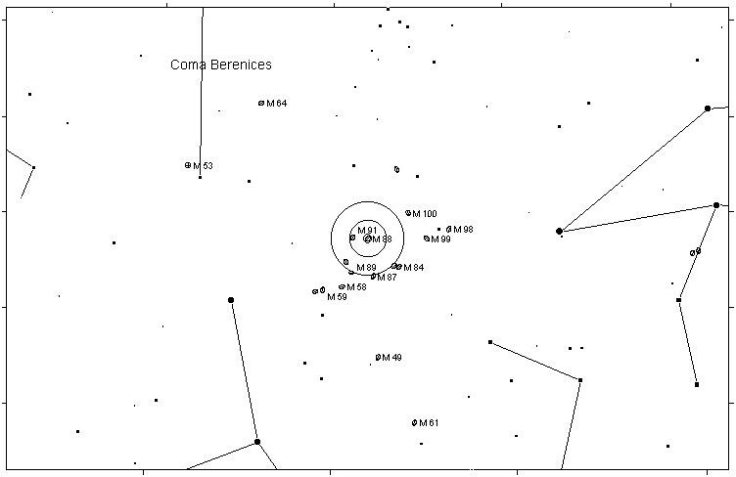
M91 SPIRAL GALAXY 10.2
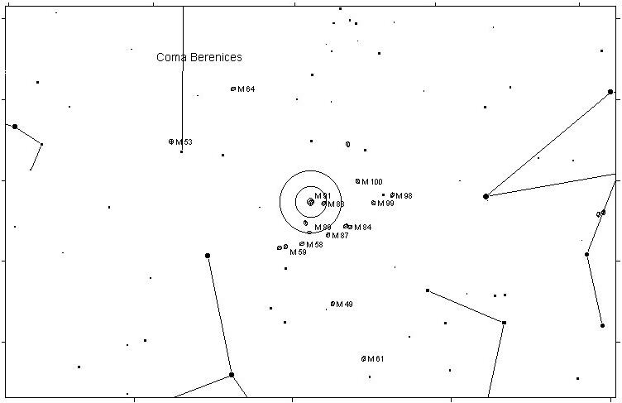

M87 ELLIPTICAL GALAXY 8.6
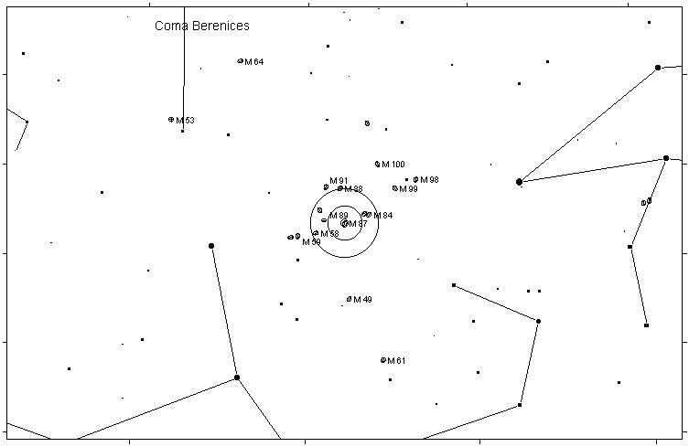
M86 ELLIPTICAL GALAXY 9.2
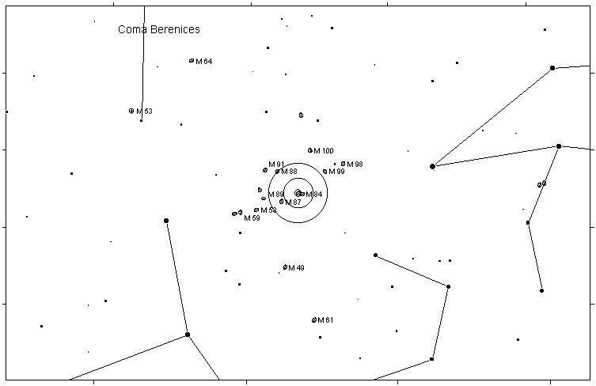

M84 ELLIPTICAL GALAXY 9.3
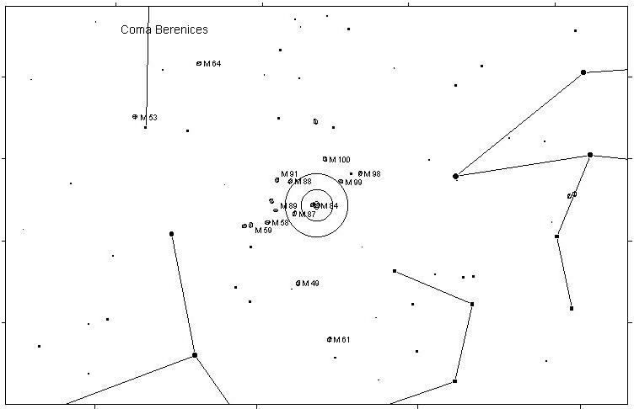
M100 SPIRAL GALAXY 9.4
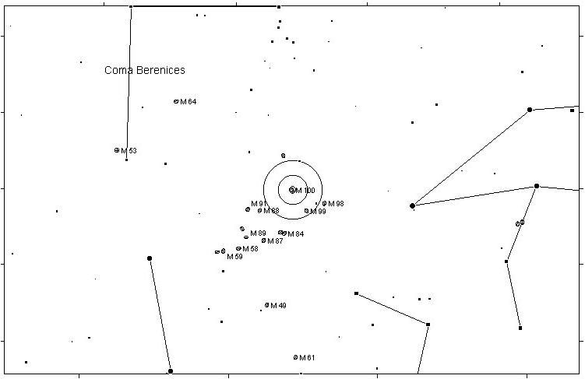

M85 ELLIPTICAL GALAXY 9.2
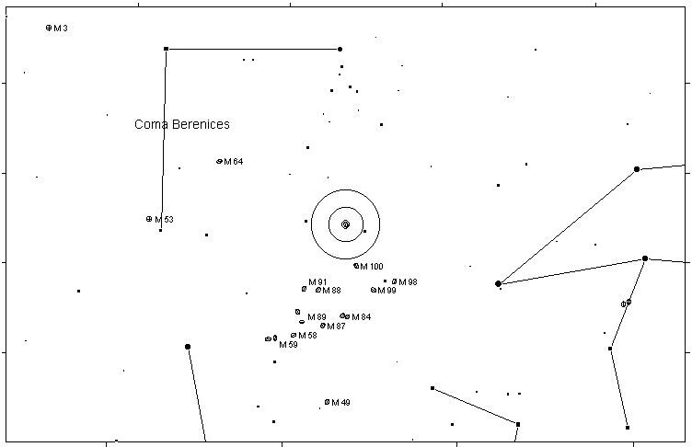
M98 SPIRAL GALAXY 10.1
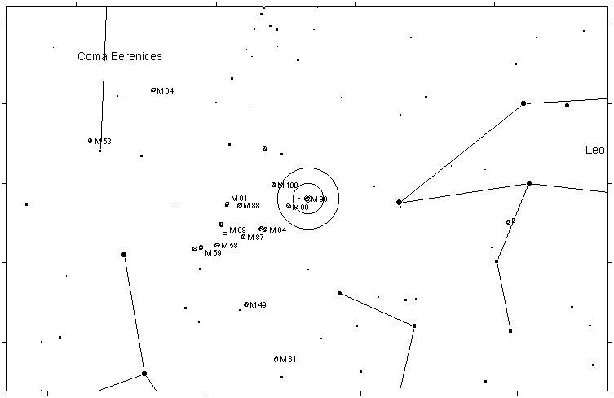

M99 SPIRAL GALAXY 9.8
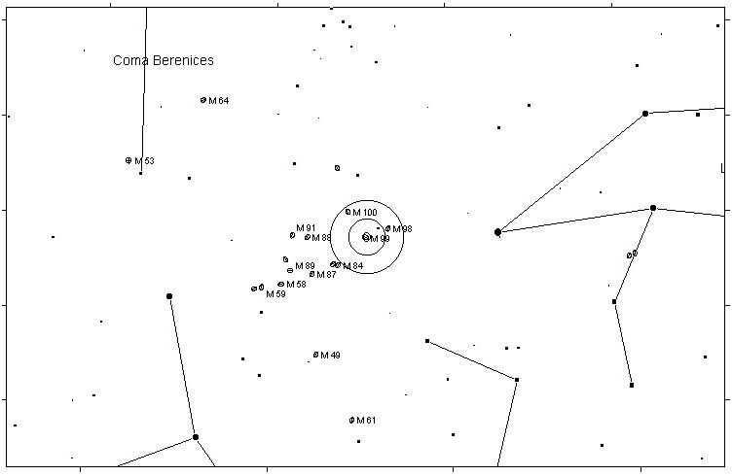
M49 ELLIPTICAL GALAXY 8.4
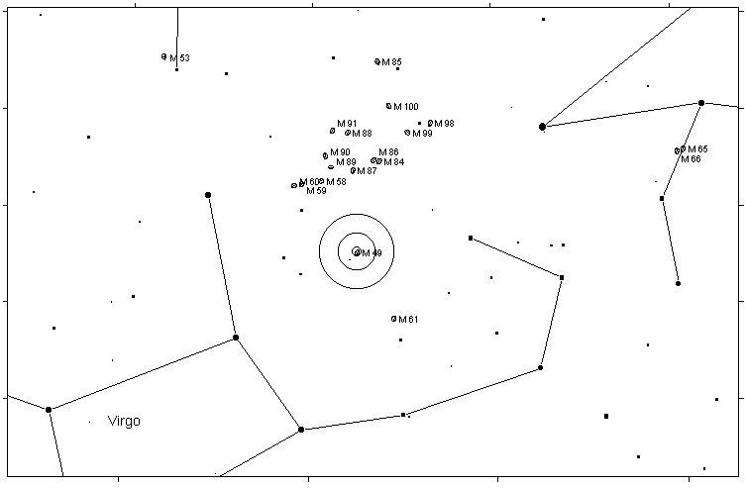

M61 SPIRAL GALAXY 9.7
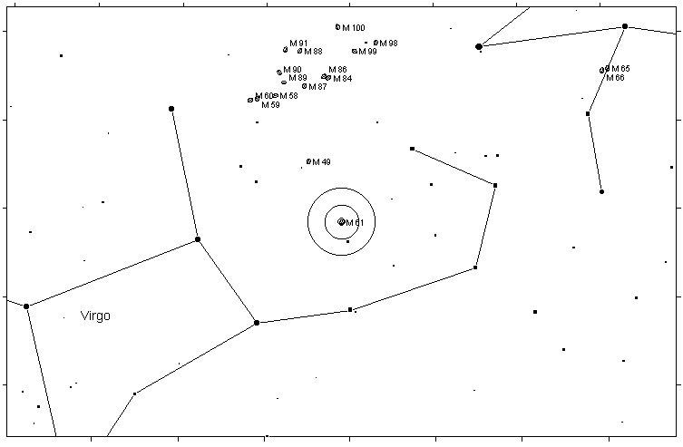
M104 SPIRAL GALAXY 8.3
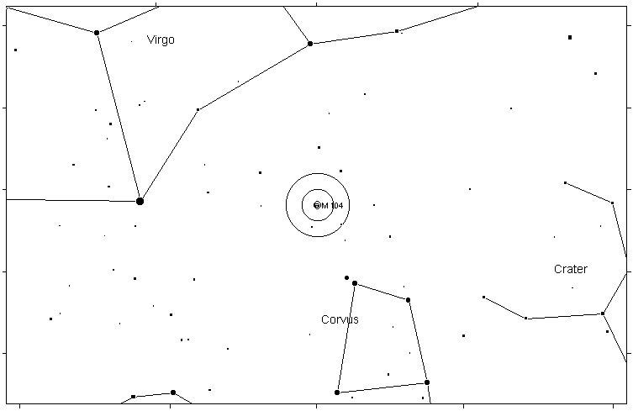

M68 GLOBULAR CLUSTER 8.2
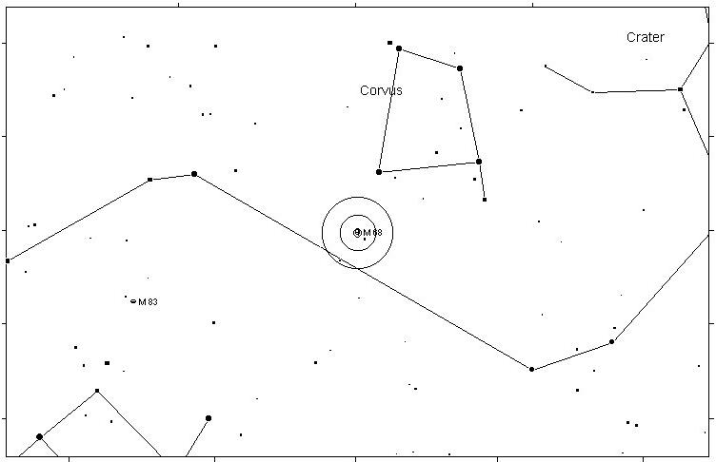
M83 SPIRAL GALAXY 7.6
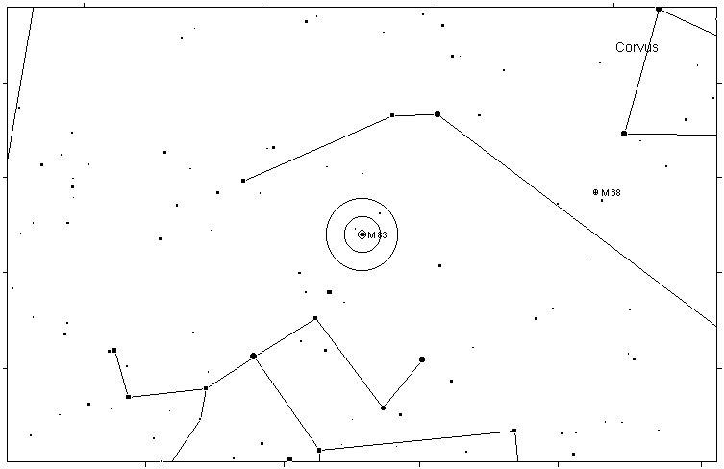

M102 ELLIPTICAL GALAXY 8.1
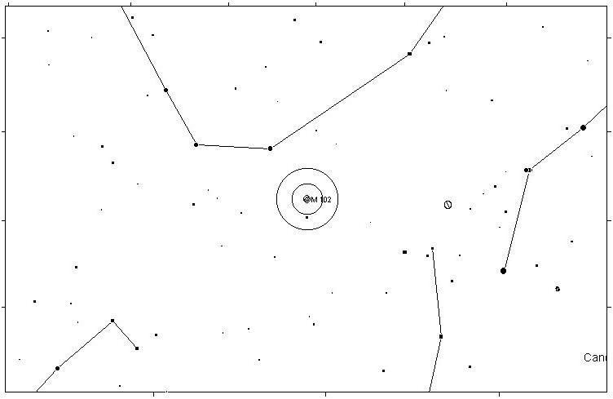
M5 GLOBULAR CLUSTER 5.8
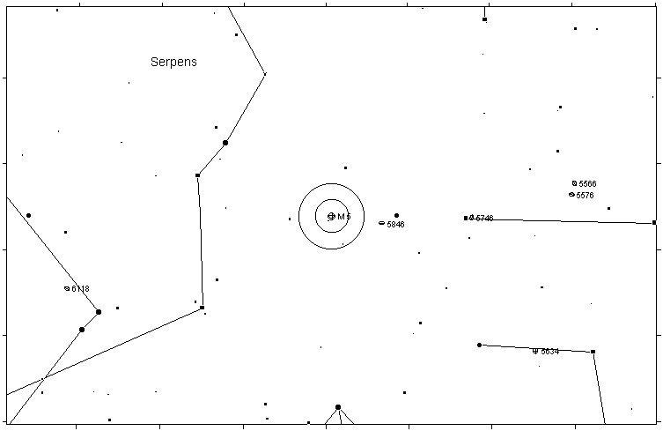

M13 GLOBULAR CLUSTER 5.9
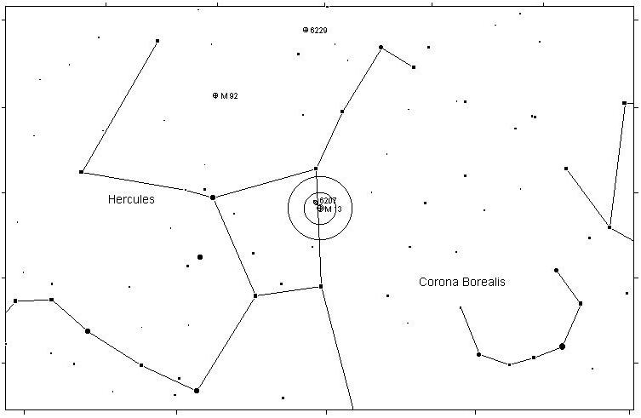
M92 GLOBULAR CLUSTER 6.5
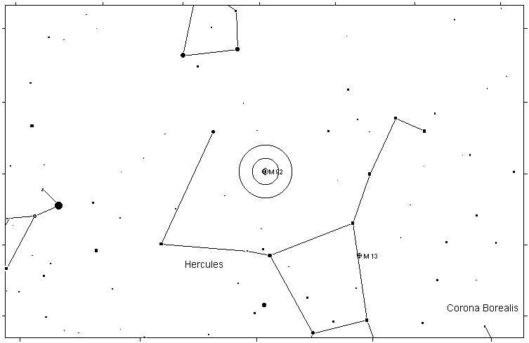

M12 GLOBULAR CLUSTER 6.6
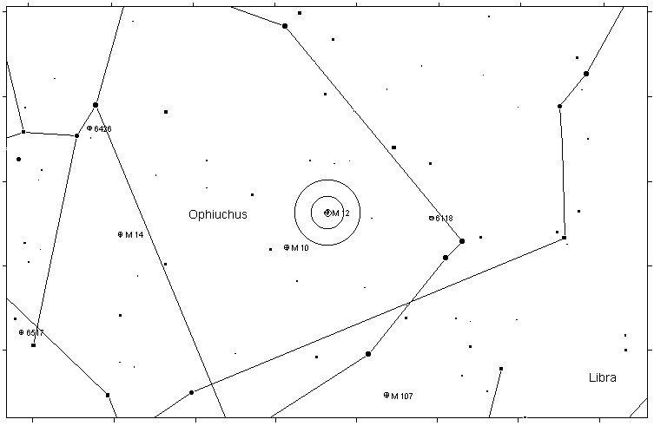
M10 GLOBULAR CLUSTER 6.6
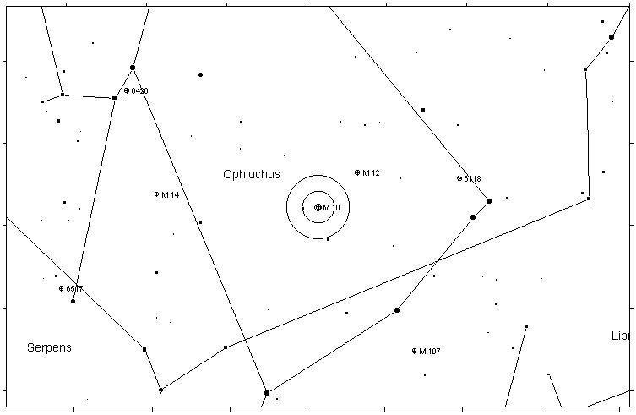

M14 GLOBULAR CLUSTER 7.6
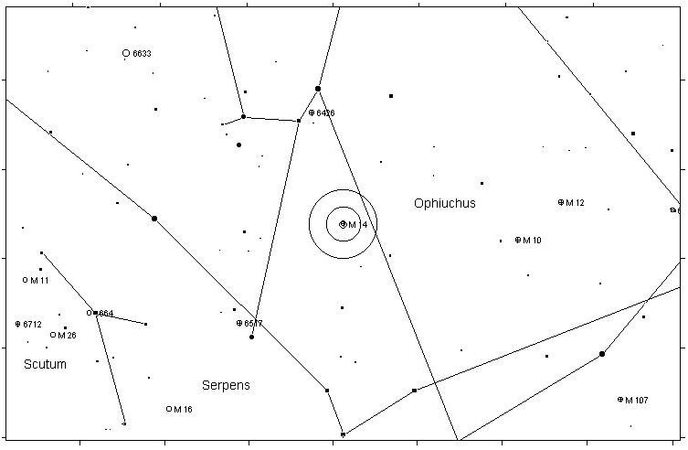
M107 GLOBULAR CLUSTER 8.1
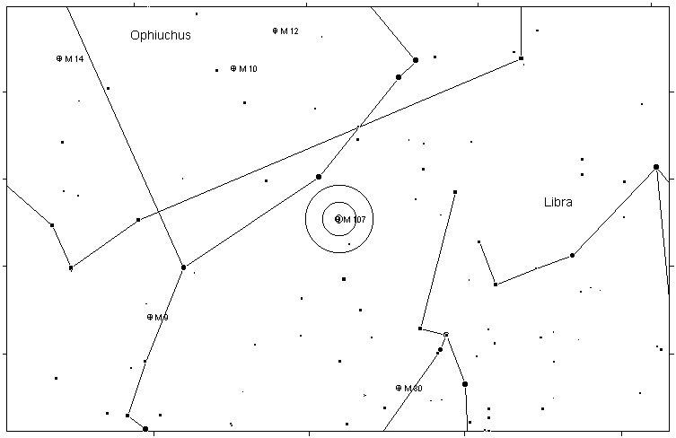

M80 GLOBULAR CLUSTER 7.2
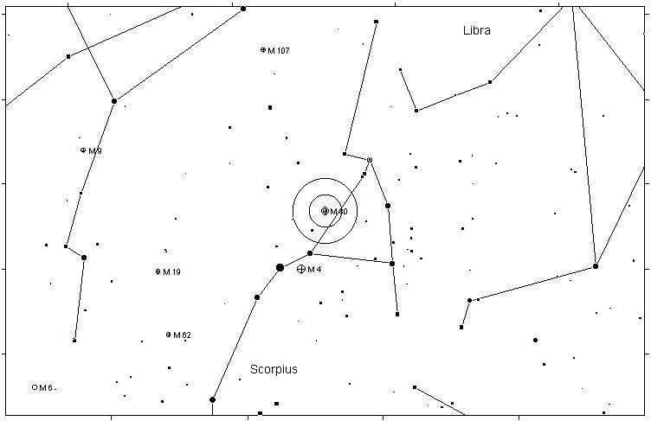
M4 GLOBULAR CLUSTER 5.9
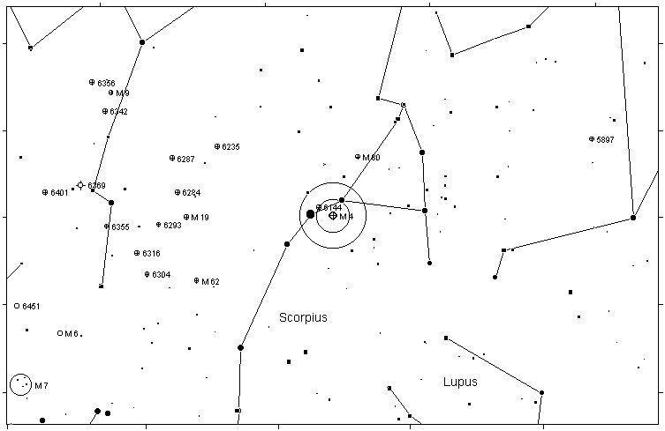

M19 GLOBULAR CLUSTER 7.2
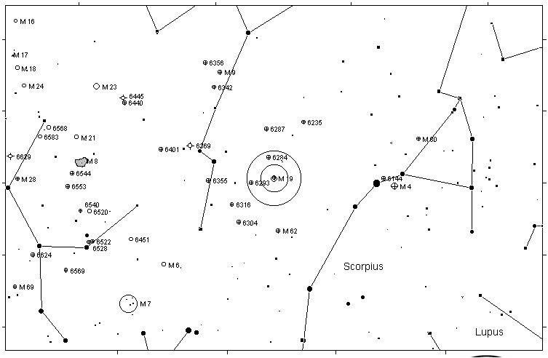
M62 OPEN CLUSTER 6.6
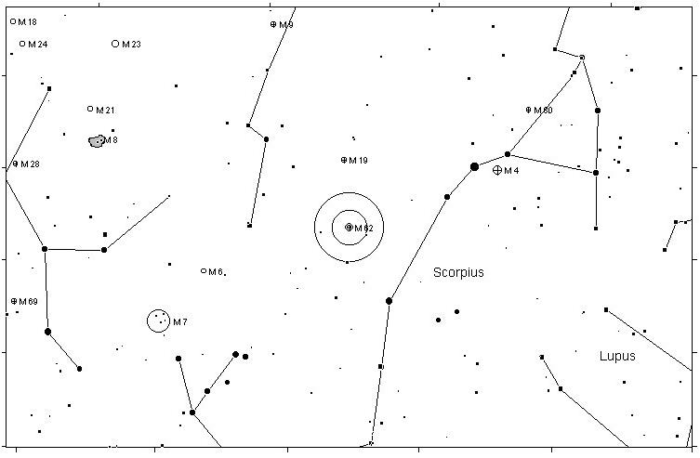

M6 OPEN CLUSTER 4.2
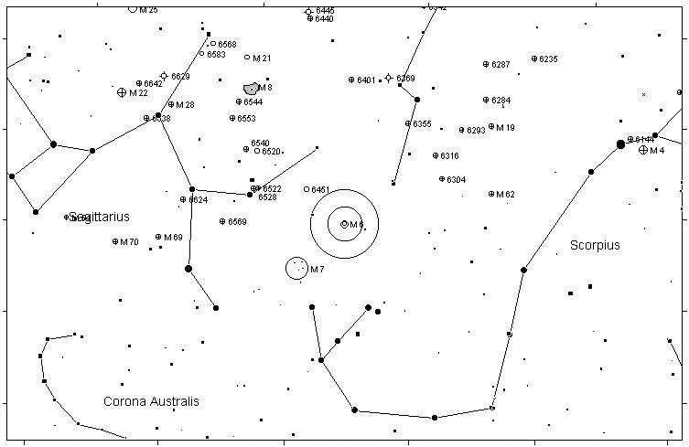
M7 OPEN CLUSTER 3.3
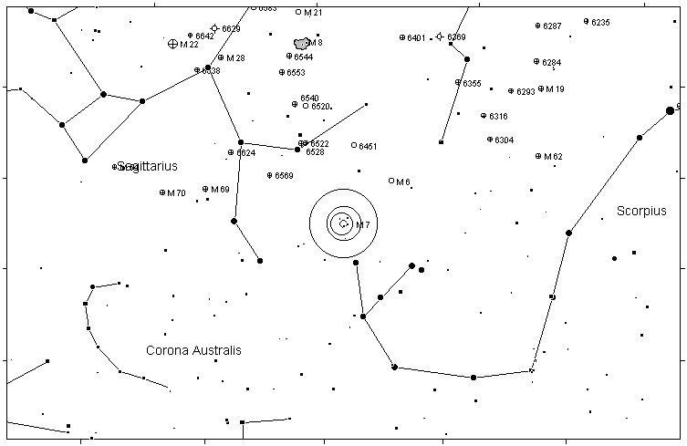

M8 DIFFUSE NEBULA 5.8
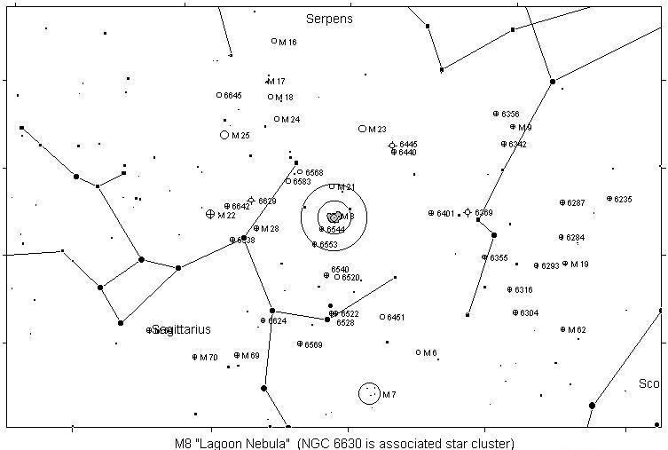
M20 DIFFUSE NEBULA 8.5
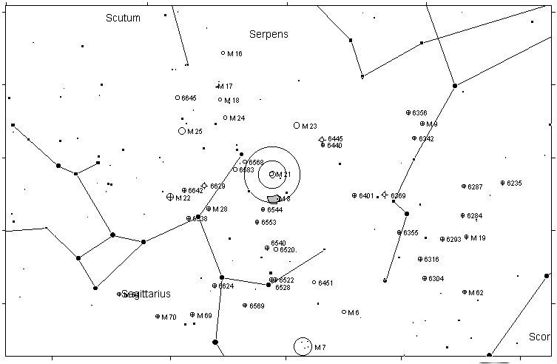

M21 OPEN CLUSTER 5.9
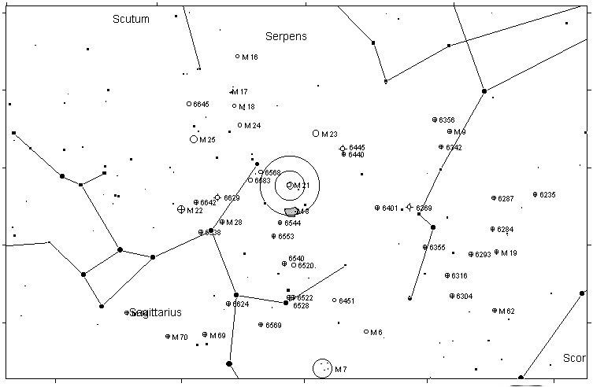
M23 OPEN CLUSTER 5.5
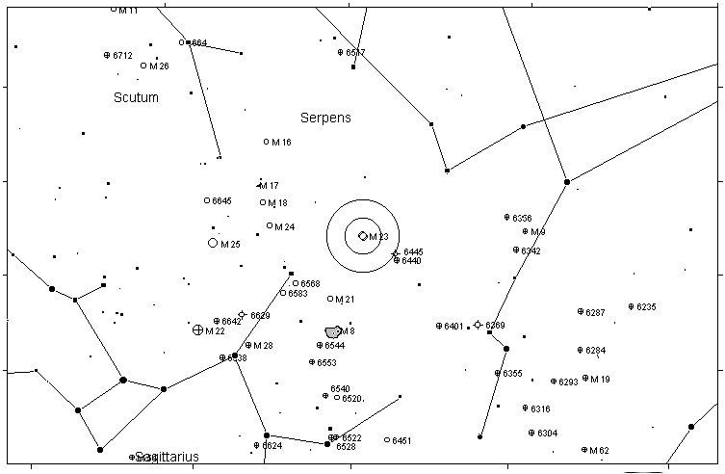

M9 GLOBULAR CLUSTER 7.9
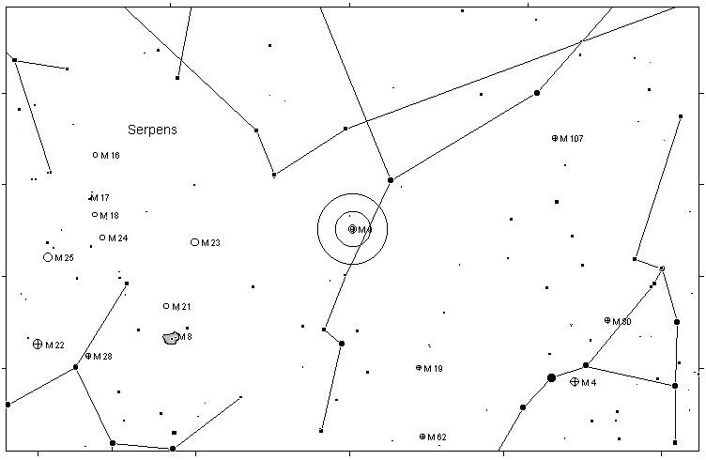
M24 STAR CLOUD 4.5
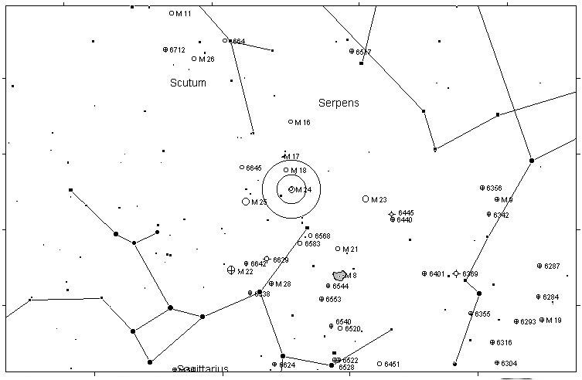

M25 OPEN CLUSTER 4.6
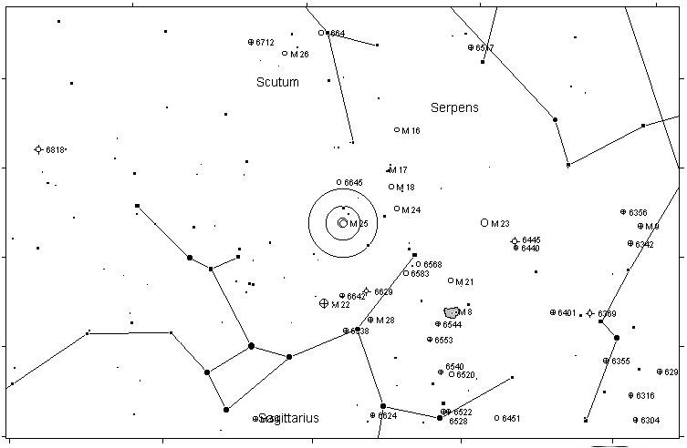
M18 OPEN CLUSTER 6.9
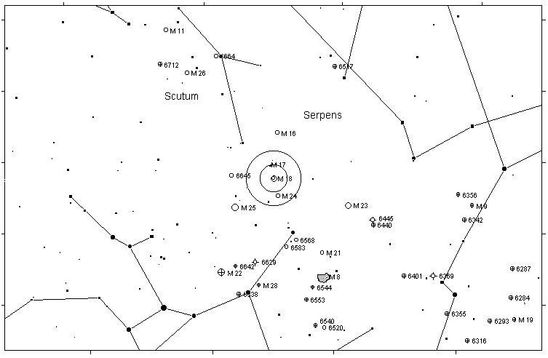

M17 DIFFUSE NEBULA 7.0
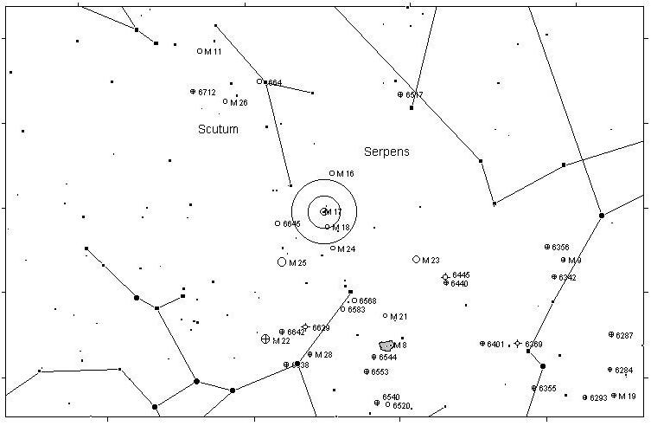
M16 OPEN CLUSTER 6.0
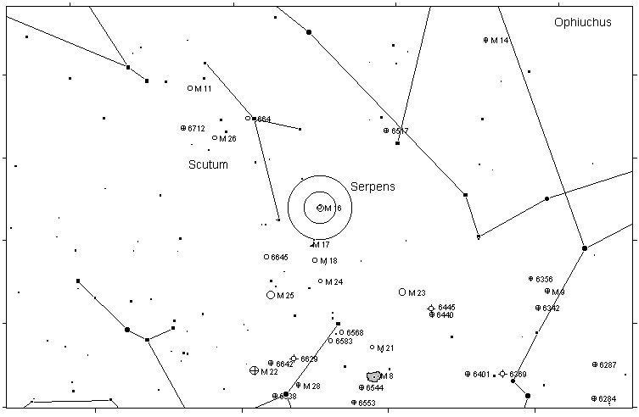

M11 OPEN CLUSTER 5.8
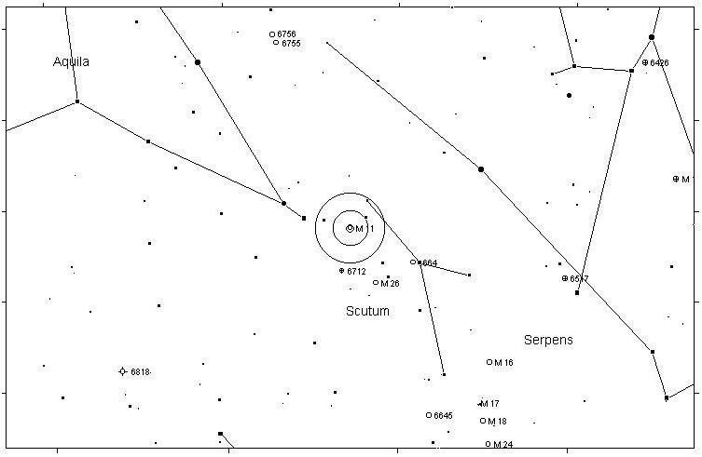
M26 OPEN CLUSTER 8.0
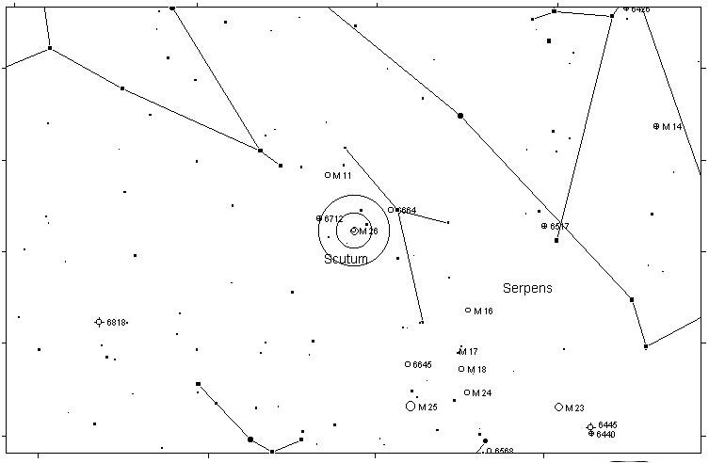

M22 GLOBULAR CLUSTER 5.1
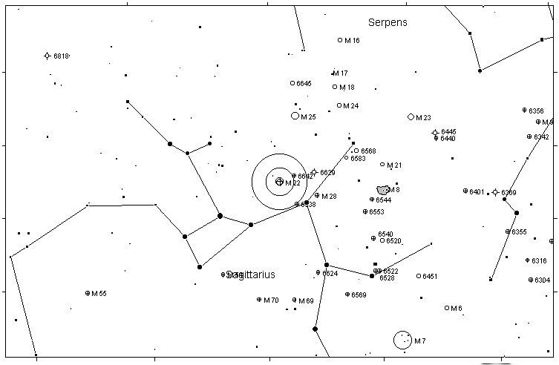
M28 GLOBULAR CLUSTER 6.9
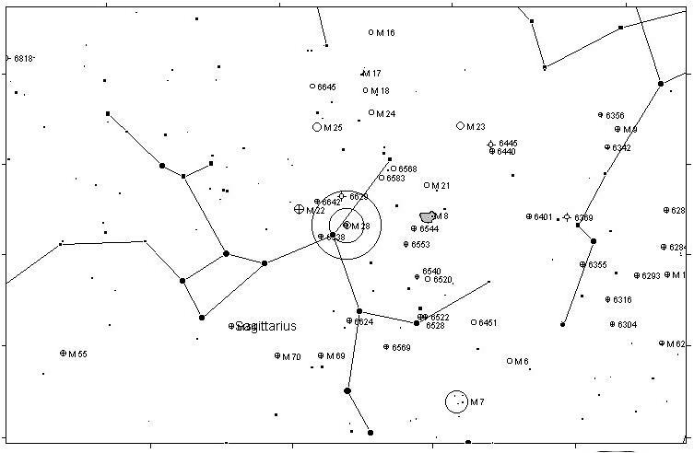

M69 GLOBULAR CLUSTER 7.7
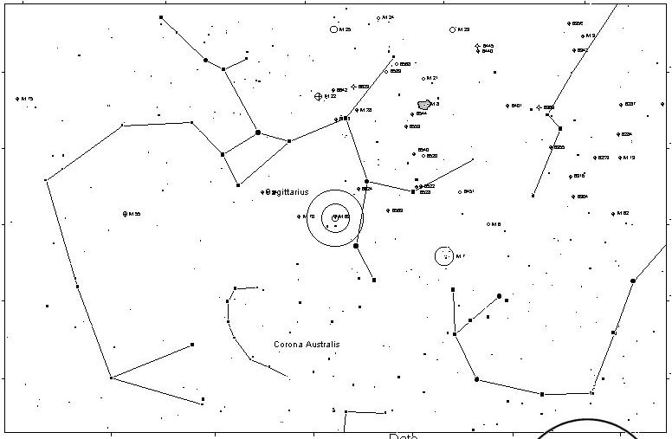
M70 GLOBULAR CLUSTER 8.1
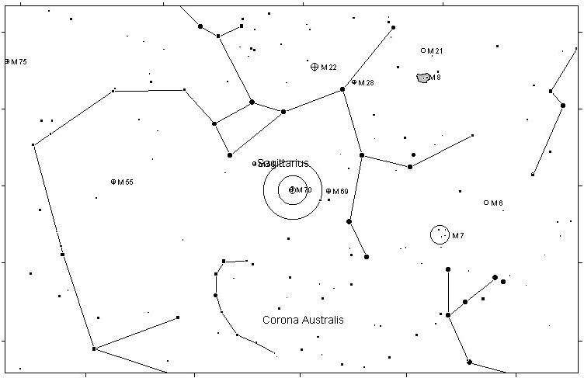

M57 PLANETARY NEBULA 9.0
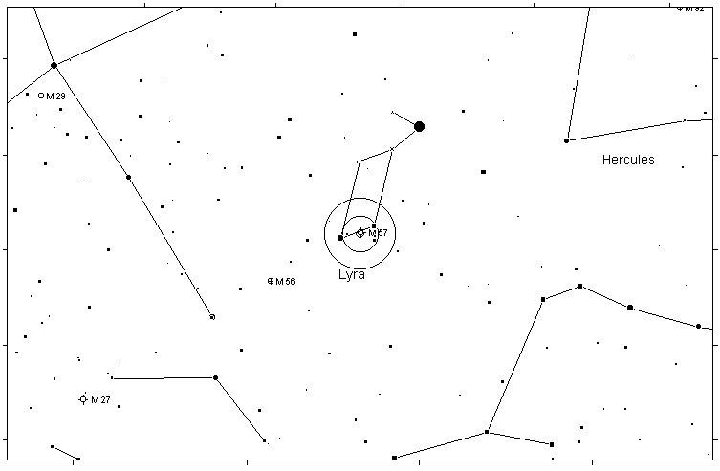
M56 GLOBULAR CLUSTER 8.2
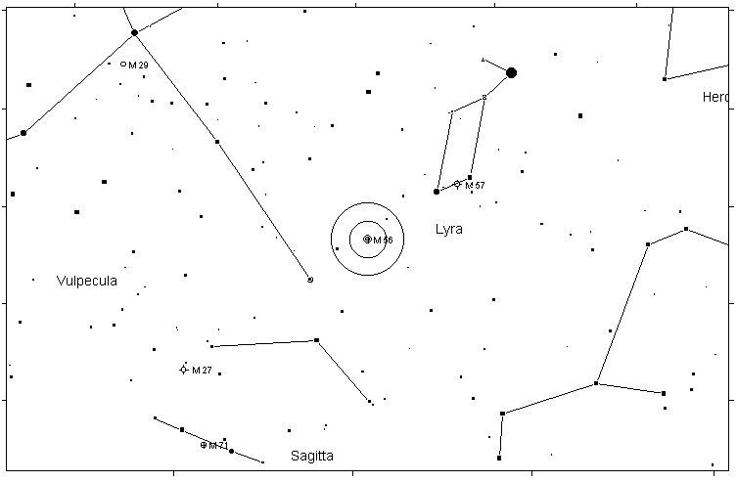

M29 OPEN CLUSTER 6.6
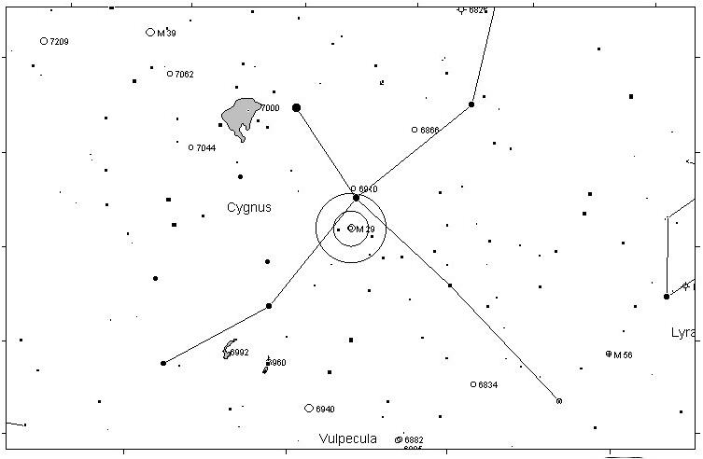
M39 OPEN CLUSTER 4.6
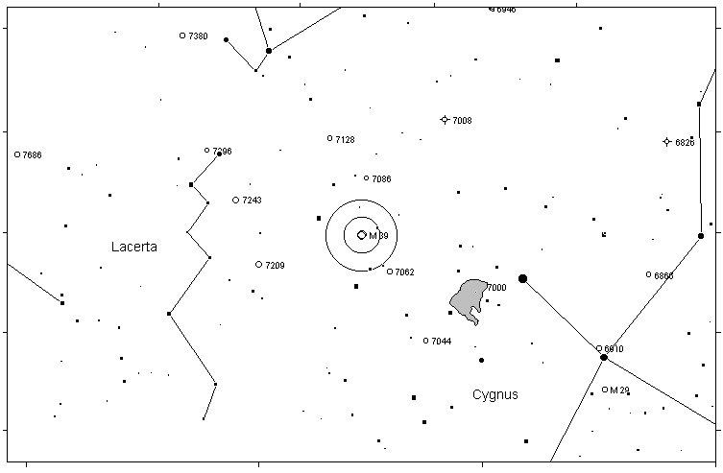

M71 GLOBULAR CLUSTER 8.3
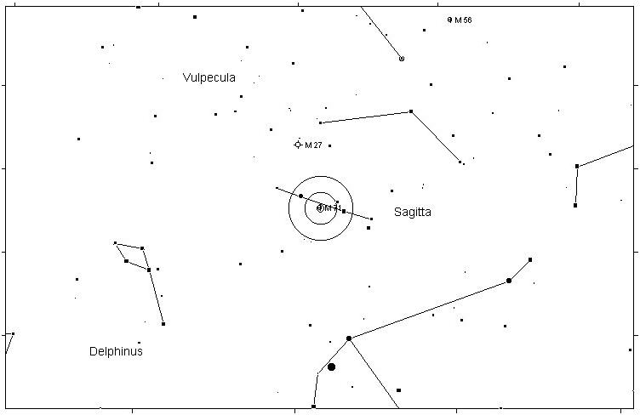
M27 PLANETARY NEBULA 8.1
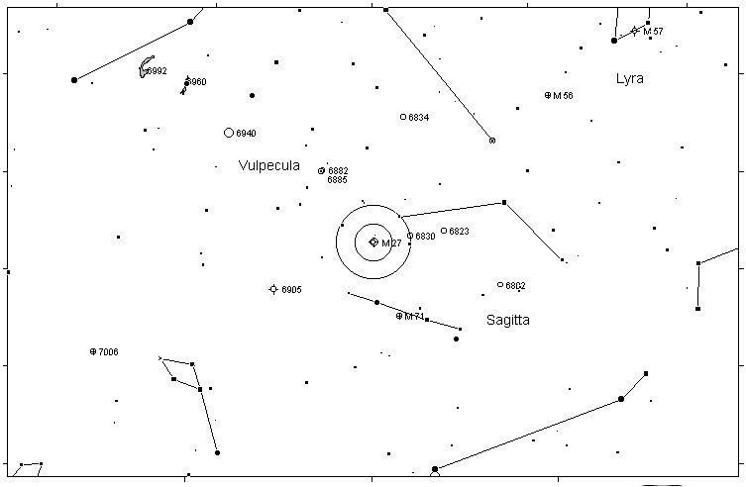

M54 GLOBULAR CLUSTER 7.6
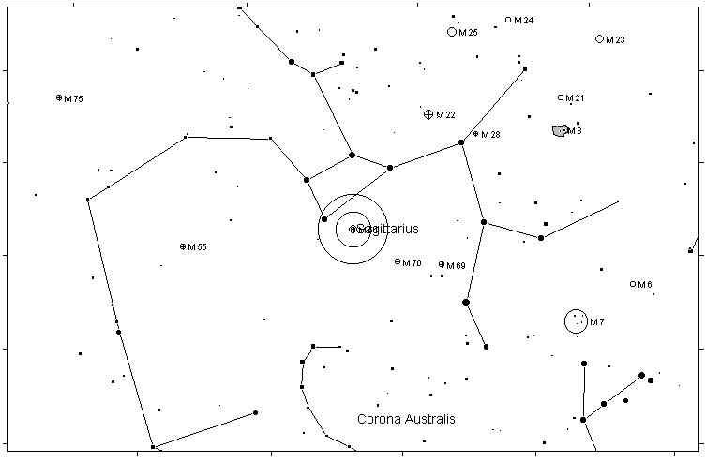
M55 GLOBULAR CLUSTER 6.3
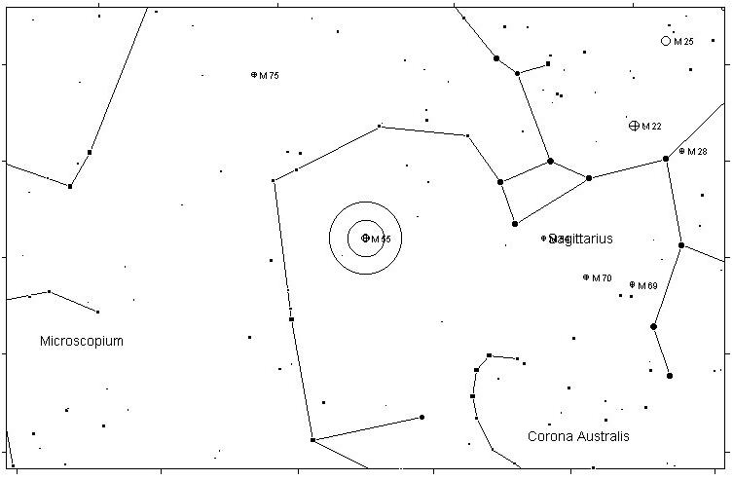

M15 GLOBULAR CLUSTER 6.4
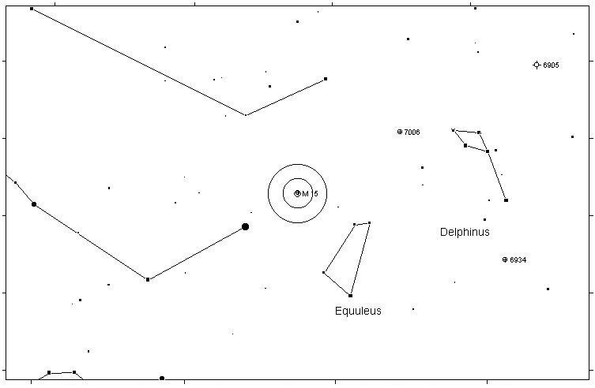
M75 GLOBULAR CLUSTER 8.6
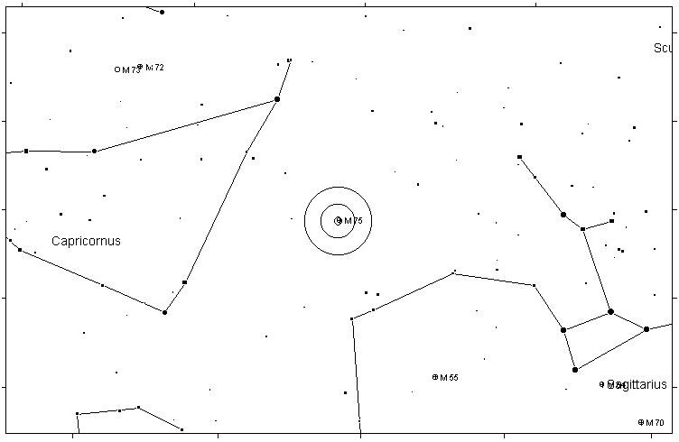

M72 GLOBULAR CLUSTER 9.4
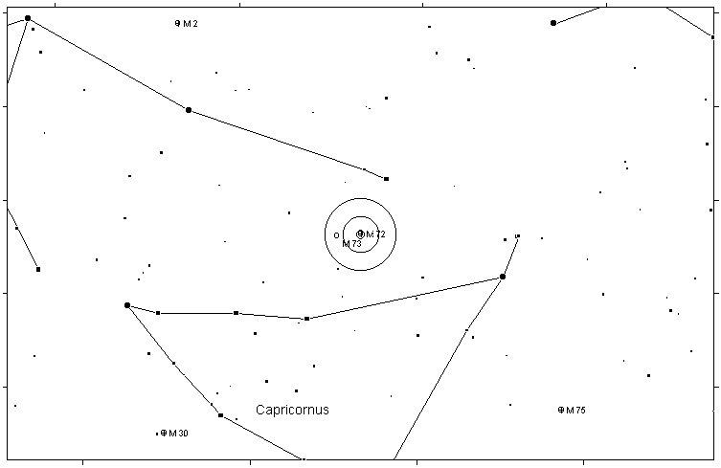
M73 ASTERISM 9.0
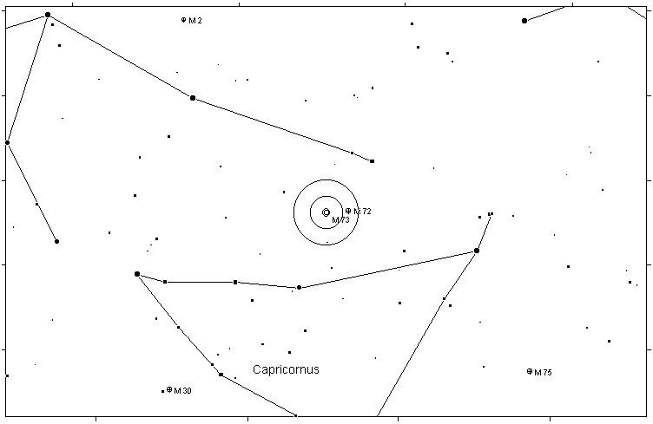

M2 GLOBULAR CLUSTER 6.5
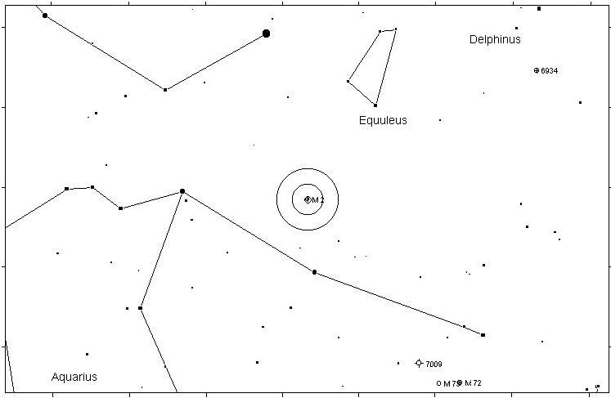
M30 GLOBULAR CLUSTER 7.5
